***University Physics Volume I***

**Unit 1: Mechanics**

**Chapter 14: Fluid Mechanics**

**Conceptual Questions**

1. Which of the following substances are fluids at room temperature and atmospheric pressure: air, mercury, water, glass?

Solution

Mercury and water are liquid at room temperature and atmospheric pressure. Air is a gas at room temperature and atmospheric pressure. Glass is an amorphous solid (non-crystalline) material at room temperature and atmospheric pressure. At one time, it was thought that glass flowed, but flowed very slowly. This theory came from the observation that old glass planes were thicker at the bottom. It is now thought unlikely that this theory is accurate.

1. Why are gases easier to compress than liquids and solids?

Solution

Gases are the easiest to compress because the molecules are very far apart compared to the distances between molecules in a solid or liquid. The molecules in liquids and solids are closer together and it requires a large force to compress them.

1. Explain how the density of air varies with altitude.

Solution

The density of air decreases with altitude. For a column of air of a constant temperature, the density decreases exponentially with altitude. This is a fair approximation, but since the temperature does change with altitude, it is only an approximation.

1. The image shows a glass of ice water filled to the brim. Will the water overflow when the ice melts? Explain your answer.

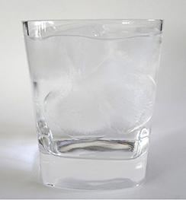

Solution

Although most materials expand when heated and contract when cooled, the density of ice increases as it is cooled. This is why ice floats. It also means that the volume of a mass of ice is greater than the same mass of liquid water. Therefore, assuming no ice was extending above the glass, the glass should not overflow when the ice melts because the volume needed to hold the melted ice is already displaced by the ice.

1. How is pressure related to the sharpness of a knife and its ability to cut?

Solution

Pressure is force divided by area. If a knife is sharp, the force applied to the cutting surface is divided over a smaller area than the same force applied with a dull knife. This means that the pressure would be greater for the sharper knife, increasing its ability to cut.

1. Why is a force exerted by a static fluid on a surface always perpendicular to the surface?

Solution

Fluids cannot withstand shearing (sideways) forces; they cannot exert shearing forces, either. Fluid pressure has no direction, being a scalar quantity. The forces due to pressure have well-defined directions: they are always exerted perpendicular to any surface.

1. Imagine that in a remote location near the North Pole, a chunk of ice floats in a lake. Next to the lake, a glacier with the same volume as the floating ice sits on land. If both chunks of ice should melt due to rising global temperatures, and the melted ice all goes into the lake, which one would cause the level of the lake to rise the most? Explain.

Solution

If the two chunks of ice had the same volume, they would produce the same volume of water. The glacier would cause the greatest rise in the lake, however, because part of the floating chunk of ice is already submerged in the lake, and is thus already contributing to the lake’s level.

1. In ballet, dancing *en pointe* (on the tips of the toes) is much harder on the toes than normal dancing or walking. Explain why, in terms of pressure.

Solution

In the toe dancing of the ballet, the same force is distributed over a smaller area, increasing the pressure.

1. Atmospheric pressure exerts a large force (equal to the weight of the atmosphere above your body—about 10 tons) on the top of your body when you are lying on the beach sunbathing. Why are you able to get up?

Solution

The pressure is acting all around your body, assuming you are not in a vacuum

1. Why does atmospheric pressure decrease more rapidly than linearly with altitude?

Solution

The density of the air near the surface has been compressed by the weight of the air above it. Moving up through the atmosphere, each successive layer has less air above it and each layer is less dense than the layer below it.

1. The image shows how sandbags placed around a leak outside a river levee can effectively stop the flow of water under the levee. Explain how the small amount of water inside the column of sandbags is able to balance the much larger body of water behind the levee.

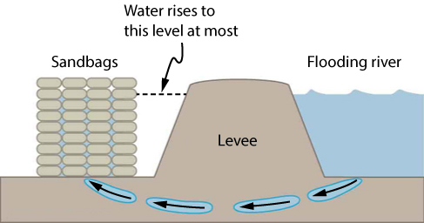

Solution

Because the river level is very high, it has started to leak under the levee. Sandbags are placed around the leak, and the water held by them rises until it is the same level as the river, at which point the water there stops rising. The sandbags will absorb water until the water reaches the height of the water in the levee.

1. Is there a net force on a dam due to atmospheric pressure? Explain your answer.

Solution

No, not a net force. The atmospheric pressure is the same on both sides of the dam.

1. Does atmospheric pressure add to the gas pressure in a rigid tank? In a toy balloon? When, in general, does atmospheric pressure not affect the total pressure in a fluid?

Solution

Atmospheric pressure does not affect the gas pressure in a rigid tank, but it does affect the pressure inside a balloon. In general, atmospheric pressure affects fluid pressure unless the fluid is enclosed in a rigid container.

1. You can break a strong wine bottle by pounding a cork into it with your fist, but the cork must press directly against the liquid filling the bottle—there can be no air between the cork and liquid. Explain why the bottle breaks only if there is no air between the cork and liquid.

Solution

The pressure from the cork is distributed through the fluid until it gets to the glass bottle, where the force is perpendicular to the glass. The pressure is large because the cross-sectional area of the cork is small. If there was air, the air compresses easily.

1. Explain why the fluid reaches equal levels on either side of a manometer if both sides are open to the atmosphere, even if the tubes are of different diameters.

Solution

The pressure of the atmosphere is due to the weight of the air above. The pressure, force per area, on the manometer will be the same at the same depth of the atmosphere.

1. Suppose the master cylinder in a hydraulic system is at a greater height than the cylinder it is controlling. Explain how this will affect the force produced at the cylinder that is being controlled.

Solution

The pressure on the cylinder that is being controlled would be the pressure applied to the master cylinder plus the pressure from the height of the fluid.

1. More force is required to pull the plug in a full bathtub than when it is empty. Does this contradict Archimedes’ principle? Explain your answer.

Solution

Not at all. Pascal’s principle says that the change in the pressure is exerted through the fluid. The reason that the full tub requires more force to pull the plug is because of the weight of the water above the plug.

1. Do fluids exert buoyant forces in a “weightless” environment, such as in the space shuttle? Explain your answer.

Solution

No. The buoyant forces are due to pressure differences at different heights or depths in a fluid. The pressure differences are due to the weight of the column of fluid above the height or depth.

1. Will the same ship float higher in salt water than in freshwater? Explain your answer.

Solution

The buoyant force is equal to the weight of the fluid displaced. The greater the density of the fluid, the less fluid that is needed to be displaced to have the weight of the object be supported and to float. Since the density of salt water is higher than that of fresh water, less salt water will be displaced, and the ship will float higher.

1. Marbles dropped into a partially filled bathtub sink to the bottom. Part of their weight is supported by buoyant force, yet the downward force on the bottom of the tub increases by exactly the weight of the marbles. Explain why.

Solution

The buoyant force is equal to the weight of the fluid displaced. This fluid is now above the marbles, still exerting a downward force. For this reason, the additional force on the bottom is equal to the weight of the marbles.

1. Many figures in the text show streamlines. Explain why fluid velocity is greatest where streamlines are closest together. (*Hint:* Consider the relationship between fluid velocity and the cross-sectional area through which the fluid flows.)

Solution

Consider two different pipes connected to a single pipe of a smaller diameter, with fluid flowing from the two pipes into the smaller pipe. Since the fluid is forced through a smaller cross-sectional area, it must move faster as the flow lines become closer together. Likewise, if a pipe with a large radius feeds into a pipe with a small radius, the stream lines will become closer together and the fluid will move faster.

1. You can squirt water from a garden hose a considerably greater distance by partially covering the opening with your thumb. Explain how this works.

Solution

When you decrease the area through which the water is flowing, the pressure increases. The fluid must be moving faster in this region because the fluid is incompressible. The fast moving fluid can go further than a slow moving fluid due to its increased kinetic energy.

1. Water is shot nearly vertically upward in a decorative fountain and the stream is observed to broaden as it rises. Conversely, a stream of water falling straight down from a faucet narrows. Explain why.

Solution

The mass of water that enters a cross-sectional area must equal the amount that leaves. From the continuity equation, we know that the density times the area times the velocity must remain constant. Since the density of the water does not change, the velocity times the cross-sectional area entering a region must equal the cross-sectional area times the velocity leaving the region. Since the velocity of the fountain stream decreases as it rises due to gravity, the area must increase. Since the velocity of the faucet stream speeds up as it falls, the area must decrease.

1. Look at the following figure. Answer the following two questions. Why is  less than atmospheric? Why is  greater than ?

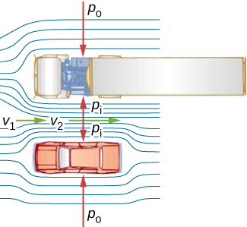

Solution

The pressure outside the truck is less than atmospheric because the air is in motion around the truck. The pressure between the car and truck is less due to the increased velocity of the fluid between the truck and car.

1. A tube with a narrow segment designed to enhance entrainment is called a Venturi, such as shown below. Venturis are very commonly used in carburetors and aspirators. How does this structure bolster entrainment?

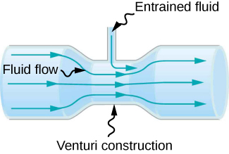

Solution

When the tube narrows, the fluid is forced to speed up, thanks to the continuity equation and the work done on the fluid. Where the tube is narrow, the pressure decreases. This means that the entrained fluid will be pushed into the narrow area.

1. Some chimney pipes have a T-shape, with a crosspiece on top that helps draw up gases whenever there is even a slight breeze. Explain how this works in terms of Bernoulli’s principle.

Solution

The entrance and exit are at the same height; therefore, any work done by the pressure increases the speed of the molecules of air. This provides a change in pressure and the air and smoke in the chimney are entrained into the stream.

1. Is there a limit to the height to which an entrainment device can raise a fluid? Explain your answer.

Solution

The work done by pressure can be used to increase the kinetic energy and to gain potential energy. As the height becomes larger, there is less energy left to give to kinetic energy. Eventually, there will be a maximum height that cannot be overcome.

1. Why is it preferable for airplanes to take off into the wind rather than with the wind?

Solution

When a plane takes off into the wind, the speed of the air is the speed of the wind plus the speed of the plane. When the plane takes off with the wind, the speed of air over the wing is the speed of the plane minus the speed of the wind.

1. Roofs are sometimes pushed off vertically during a tropical cyclone, and buildings sometimes explode outward when hit by a tornado. Use Bernoulli’s principle to explain these phenomena.

Solution

Because of the speed of the air outside the building, the pressure outside the house decreases. The greater pressure inside the building can essentially blow off the roof or cause the building to explode.

1. It is dangerous to stand close to railroad tracks when a rapidly moving commuter train passes. Explain why atmospheric pressure would push you toward the moving train.

Solution

The fast moving air on the side of you near the train creates a region of low pressure. The atmospheric pressure on the side of you away from the train creates a net force that pushes you toward the train.

1. Water pressure inside a hose nozzle can be less than atmospheric pressure due to the Bernoulli effect. Explain in terms of energy how the water can emerge from the nozzle against the opposing atmospheric pressure.

Solution

The air inside the hose has kinetic energy due to its motion. The kinetic energy can be used to do work against the pressure difference.

1. David rolled down the window on his car while driving on the freeway. An empty plastic bag on the floor promptly flew out the window. Explain why.

Solution

The air moving around the car produces a reduced pressure and the higher pressure inside the car blows the plastic bag outside the window.

1. Based on Bernoulli’s equation, what are three forms of energy in a fluid? (Note that these forms are conservative, unlike heat transfer and other dissipative forms not included in Bernoulli’s equation.)

Solution

Potential energy due to position, kinetic energy due to velocity, and the work done by a pressure difference.

1. The old rubber boot shown below has two leaks. To what maximum height can the water squirt from Leak 1? How does the velocity of water emerging from Leak 2 differ from that of Leak 1? Explain your responses in terms of energy.

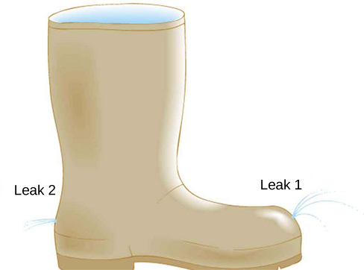

Solution

Leak 1 points up while leak two points horizontally. Both leaks appear to be at the same height, so the velocity of the fluid leaving the boot is the same. As Leak 2 leaves the boot, the velocity in the *x* direct will remain constant while the velocity in the *y*-direction will increase due to the loss of potential energy due to the height. In Leak 1, the *x*-velocity will be constant and the *y*-velocity will decrease as the water gains potential energy and then increase in the negative direction as it loses potential energy.

1. Water pressure inside a hose nozzle can be less than atmospheric pressure due to the Bernoulli effect. Explain in terms of energy how the water can emerge from the nozzle against the opposing atmospheric pressure.

Solution

The water has kinetic energy due to its motion. This energy can be converted into work against the difference in pressure.

1. Explain why the viscosity of a liquid decreases with temperature, that is, how might an increase in temperature reduce the effects of cohesive forces in a liquid? Also explain why the viscosity of a gas increases with temperature, that is, how does increased gas temperature create more collisions between atoms and molecules?

Solution

In a liquid, the molecules are relatively close to one another and there are cohesive forces between molecules. Heating the fluid expands the distance between the molecules, reducing the cohesive forces, and also adds energy, which gives the molecules the ability to break free of these forces. In a gas, increasing the temperature increases the kinetic energy of the molecules and thus their speed. This increases the interaction between molecules.

1. When paddling a canoe upstream, it is wisest to travel as near to the shore as possible. When canoeing downstream, it is generally better to stay near the middle. Explain why.

Solution

The water in the center of the stream is moving faster than the water near the shore due to resistance between the water and the shore and between the layers of fluid. There is also probably more turbulence near the shore, which will also slow the water down. When paddling up stream, the water pushes against the canoe, so it is better to stay near the shore to minimize the force pushing against the canoe. When moving downstream, the water pushes the canoe, increasing its velocity, so it is better to stay in the middle of the stream to maximize this effect.

1. Plumbing usually includes air-filled tubes near water faucets (see the following figure). Explain why they are needed and how they work.

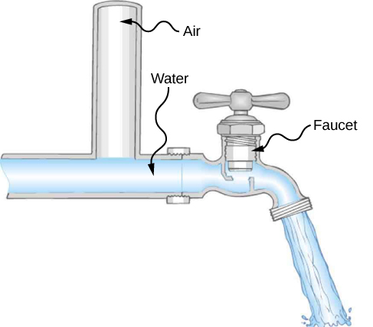

Solution

The tube allows air trapped in the pipe to escape. A bubble of air would reduce the diameter of the tube and promote turbulence.

1. Doppler ultrasound can be used to measure the speed of blood in the body. If there is a partial constriction of an artery, where would you expect blood speed to be greatest: at or after the constriction? What are the two distinct causes of higher resistance in the constriction?

Solution

You would expect the speed to be slower after the obstruction. Resistance is increased due to the reduction in size of the opening, and turbulence will be created because of the obstruction, both of which will clause the fluid to slow down.

1. Sink drains often have a device such as that shown below to help speed the flow of water. How does this work?

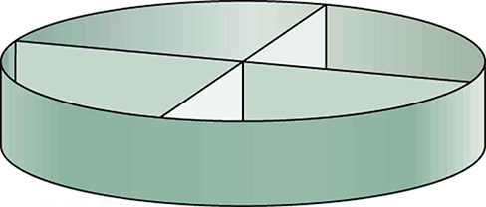

Solution

The device aligns the water into streams of water, tending towards laminar, rather than turbulent flow.

**Problems**

1. Gold is sold by the troy ounce (31.103 g). What is the volume of 1 troy ounce of pure gold?

Solution

1.610 

1. Mercury is commonly supplied in flasks containing 34.5 kg (about 76 lb.). What is the volume in liters of this much mercury?

Solution

2.54 L

1. What is the mass of a deep breath of air having a volume of 2.00 L? Discuss the effect taking such a breath has on your body’s volume and density.

Solution

The mass is 2.58 g. The volume of your body increases by the volume of air you inhale. The average density of your body decreases when you take a deep breath because the density of air is substantially smaller than the average density of the body.

1. A straightforward method of finding the density of an object is to measure its mass and then measure its volume by submerging it in a graduated cylinder. What is the density of a 240-g rock that displaces  of water? (Note that the accuracy and practical applications of this technique are more limited than a variety of others that are based on Archimedes’ principle.)

Solution

2.70 g/cm3

1. Suppose you have a coffee mug with a circular cross-section and vertical sides (uniform radius). What is its inside radius if it holds 375 g of coffee when filled to a depth of 7.50 cm? Assume coffee has the same density as water.

Solution

3.99 cm

1. A rectangular gasoline tank can hold 50.0 kg of gasoline when full. What is the depth of the tank if it is 0.500-m wide by 0.900-m long? (b) Discuss whether this gas tank has a reasonable volume for a passenger car.

Solution

a. 0.163 m; b. The volume of this gasoline tank is 19.4 gallons, quite reasonably sized for a passenger car.

1. A trash compactor can compress its contents to 0.350 times their original volume. Neglecting the mass of air expelled, by what factor is the density of the rubbish increased?

Solution

2.86 times denser

1. A 2.50-kg steel gasoline can holds 20.0 L of gasoline when full. What is the average density of the full gas can, taking into account the volume occupied by steel as well as by gasoline?

Solution

7.9 × 102 kg/m3

1. What is the density of 18.0-karat gold that is a mixture of 18 parts gold, 5 parts silver, and 1 part copper? (These values are parts by mass, not volume.) Assume that this is a simple mixture having an average density equal to the weighted densities of its constituents.

Solution

15.6 g/cm3

1. The tip of a nail exerts tremendous pressure when hit by a hammer because it exerts a large force over a small area. What force must be exerted on a nail with a circular tip of 1.00-mm diameter to create a pressure of 3.00 × 109 N/m2? (This high pressure is possible because the hammer striking the nail is brought to rest in such a short distance.)

Solution



1. A glass tube contains mercury. What would be the height of the column of mercury which would create pressure equal to 1.00 atm?

Solution



1. The greatest ocean depths on Earth are found in the Marianas Trench near the Philippines. Calculate the pressure due to the ocean at the bottom of this trench, given its depth is 11.0 km and assuming the density of seawater is constant all the way down.

Solution



1. Verify that the SI unit of  is .

Solution

proof 

1. What pressure is exerted on the bottom of a gas tank that is 0.500-m wide and 0.900-m long and can hold 50.0 kg of gasoline when full?

Solution



1. A dam is used to hold back a river. The dam has a height  and a width Assume that the density of the water is  (a) Determine the net force on the dam. (b) Why does the thickness of the dam increase with depth?

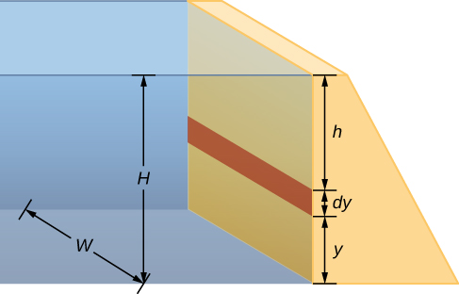

Solution

a. Pressureat:









b. The pressure increases as the depth increases, so the dam must be built thicker toward the bottom to withstand the greater pressure.

1. Find the gauge and absolute pressures in the balloon and peanut jar shown in the following figure, assuming the manometer connected to the balloon uses water and the manometer connected to the jar contains mercury. Express in units of centimeters of water for the balloon and millimeters of mercury for the jar, taking  for each.

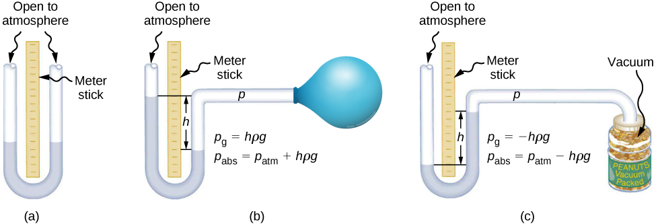

Solution

Balloon: ; Jar: 710 mm Hg

1. How tall must a water-filled manometer be to measure blood pressure as high as 300 mm Hg?

Solution

4.08 m

1. Assuming bicycle tires are perfectly flexible and support the weight of bicycle and rider by pressure alone, calculate the total area of the tires in contact with the ground if a bicycle and rider have a total mass of 80.0 kg, and the gauge pressure in the tires is .

Solution



1. How much pressure is transmitted in the hydraulic system considered in Example: “Calculating Force on Wheel Cylinders: Pascal Puts on the Brakes”? Express your answer in atmospheres.

Solution

251 atm

1. What force must be exerted on the master cylinder of a hydraulic lift to support the weight of a 2000-kg car (a large car) resting on a second cylinder? The master cylinder has a 2.00-cm diameter and the second cylinder has a 24.0-cm diameter.

Solution

136 N

1. A host pours the remnants of several bottles of wine into a jug after a party. The host then inserts a cork with a 2.00-cm diameter into the bottle, placing it in direct contact with the wine. The host is amazed when the host pounds the cork into place and the bottom of the jug (with a 14.0-cm diameter) breaks away. Calculate the extra force exerted against the bottom if he pounded the cork with a 120-N force.

Solution



1. A certain hydraulic system is designed to exert a force 100 times as large as the one put into it. (a) What must be the ratio of the area of the cylinder that is being controlled to the area of the master cylinder? (b) What must be the ratio of their diameters? (c) By what factor is the distance through which the output force moves reduced relative to the distance through which the input force moves? Assume no losses due to friction.

Solution

a. 100; b. 1/100; c. This tells us that the distance through which the output force moves is reduced by a factor of 100, relative to the distance through which the input force moves.

1. Verify that work input equals work output for a hydraulic system assuming no losses due to friction. Do this by showing that the distance the output force moves is reduced by the same factor that the output force is increased. Assume the volume of the fluid is constant. What effect would friction within the fluid and between components in the system have on the output force? How would this depend on whether or not the fluid is moving?

Solution

If the system is not moving, the friction would not play a role. With friction, we know there are losses, so that  therefore, the work output is less than the work input. In other words, to account for friction, you would need to push harder on the input piston than was calculated.

1. What fraction of ice is submerged when it floats in freshwater, given the density of water at  is very close to 1000 kg/m3?

Solution

91.7%

1. If a person’s body has a density of 995 kg/m3, what fraction of the body will be submerged when floating gently in (a) freshwater? (b) In salt water with a density of 1027 kg/m3?

Solution

a. 99.5% submerged; b. 96.9% submerged

1. A rock with a mass of 540 g in air is found to have an apparent mass of 342 g when submerged in water. (a) What mass of water is displaced? (b) What is the volume of the rock? (c) What is its average density? Is this consistent with the value for granite?

Solution

a. 198 g; b. 198 cm3; c. 2.73 g/cm3; the calculated density is consistent with granite

1. Archimedes’ principle can be used to calculate the density of a fluid as well as that of a solid. Suppose a chunk of iron with a mass of 390.0 g in air is found to have an apparent mass of 350.5 g when completely submerged in an unknown liquid. (a) What mass of fluid does the iron displace? (b) What is the volume of iron, using its density as given in the following table? (c) Calculate the fluid’s density and identify it.

|  |  |  |  |  |  |
| --- | --- | --- | --- | --- | --- |
| Solids  (0.0 ) | | Liquids  (0.0 ) | | Gases  (0.0  101.3 kPa) | |
| Substance |  | Substance |  | Substance |  |
| Aluminum |  | Benzene |  | Air |  |
| Bone |  | Blood |  | Carbon dioxide |  |
| Brass |  | Ethyl alcohol |  | Carbon monoxide |  |
| Concrete |  | Gasoline |  | Helium |  |
| Copper |  | Glycerin |  | Hydrogen |  |
| Cork |  | Mercury |  | Methane |  |
| Earth’s crust |  | Olive oil |  | Nitrogen |  |
| Glass |  |  |  | Nitrous oxide |  |
| Gold |  |  |  | Oxygen |  |
| Granite |  |  |  |  |  |
| Iron |  |  |  |  |  |
| Lead |  |  |  |  |  |
| Oak |  |  |  |  |  |
| Pine |  |  |  |  |  |
| Platinum |  |  |  |  |  |
| Polystyrene |  |  |  |  |  |
| Tungsten |  |  |  |  |  |
| Uranium |  |  |  |  |  |

Solution

a. 39.5 g; b. ; c. 0.79 g/cm3; ethyl alcohol

1. Calculate the buoyant force on a 2.00-L helium balloon. (b) Given the mass of the rubber in the balloon is 1.50 g, what is the net vertical force on the balloon if it is let go? Neglect the volume of the rubber.

Solution

a. ; b. 

1. What is the density of a woman who floats in fresh water with  of her volume above the surface? (This could be measured by placing her in a tank with marks on the side to measure how much water she displaces when floating and when held under water.) (b) What percent of her volume is above the surface when she floats in seawater?

Solution

a. 960 kg/m3; b. 6.34%; She floats higher in seawater.

1. A man has a mass of 80 kg and a density of 955 kg/m3 (excluding the air in his lungs). (a) Calculate his volume. (b) Find the buoyant force air exerts on him. (c) What is the ratio of the buoyant force to his weight?

Solution

a. ; b. 1.02 N; c. 

1. A simple compass can be made by placing a small bar magnet on a cork floating in water. (a) What fraction of a plain cork will be submerged when floating in water? (b) If the cork has a mass of 10.0 g and a 20.0-g magnet is placed on it, what fraction of the cork will be submerged? (c) Will the bar magnet and cork float in ethyl alcohol?

Solution

a. 0.24; b. 0.72; c. Yes, the cork will float in ethyl alcohol.

1. What percentage of an iron anchor’s weight will be supported by buoyant force when submerged in salt water?

Solution

13%

1. Referring to the following figure, prove that the buoyant force on the cylinder is equal to the weight of the fluid displaced (Archimedes’ principle). You may assume that the buoyant force is  and that the ends of the cylinder have equal areas *A.* Note that the volume of the cylinder (and that of the fluid it displaces) equals 

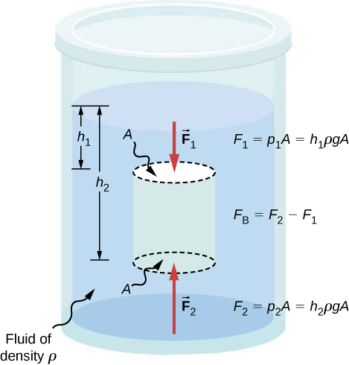

Solution



1. A 75.0-kg man floats in freshwater with 3.00% of his volume above water when his lungs are empty, and 5.00% of his volume above water when his lungs are full. Calculate the volume of air he inhales—called his lung capacity—in liters. (b) Does this lung volume seem reasonable?

Solution

a. 1.63 L; b. It is reasonable.

1. What is the average flow rate in  of gasoline to the engine of a car traveling at 100 km/h if it averages 10.0 km/L?

Solution

2.77 

1. The heart of a resting adult pumps blood at a rate of 5.00 L/min. (a) Convert this to . (b) What is this rate in ?

Solution

a. ; b. 

1. The Huka Falls on the Waikato River is one of New Zealand’s most visited natural tourist attractions. On average, the river has a flow rate of about 300,000 L/s. At the gorge, the river narrows to 20-m wide and averages 20-m deep. (a) What is the average speed of the river in the gorge? (b) What is the average speed of the water in the river downstream of the falls when it widens to 60 m and its depth increases to an average of 40 m?

Solution

a. 0.75 m/s; b. 0.13 m/s

1. (a) Estimate the time it would take to fill a private swimming pool with a capacity of 80,000 L using a garden hose delivering 60 L/min. (b) How long would it take if you could divert a moderate size river, flowing at  into the pool?

Solution

a. 22 h; b. 0.016 s

1. What is the fluid speed in a fire hose with a 9.00-cm diameter carrying 80.0 L of water per second? (b) What is the flow rate in cubic meters per second? (c) Would your answers be different if salt water replaced the fresh water in the fire hose?

Solution

a. 12.6 m/s; b. ; c. No, the flow rate and the velocity are independent of the density of the fluid.

1. Water is moving at a velocity of 2.00 m/s through a hose with an internal diameter of 1.60 cm. (a) What is the flow rate in liters per second? (b) The fluid velocity in this hose’s nozzle is 15.0 m/s. What is the nozzle’s inside diameter?

Solution

a. 0.402 L/s; b. 0.584 cm

1. Prove that the speed of an incompressible fluid through a constriction, such as in a Venturi tube, increases by a factor equal to the square of the factor by which the diameter decreases. (The converse applies for flow out of a constriction into a larger-diameter region.)

Solution

If the fluid is incompressible, the flow rate through both sides will be equal:

 or 

1. Water emerges straight down from a faucet with a 1.80-cm diameter at a speed of 0.500 m/s. (Because of the construction of the faucet, there is no variation in speed across the stream.) (a) What is the flow rate in ? (b) What is the diameter of the stream 0.200 m below the faucet? Neglect any effects due to surface tension.

Solution

a.; b. 0.890 cm

1. Verify that pressure has units of energy per unit volume.

Solution



1. Suppose you have a wind speed gauge like the pitot tube shown in the following figure. By what factor must wind speed increase to double the value of *h* in the manometer? Is this independent of the moving fluid and the fluid in the manometer?

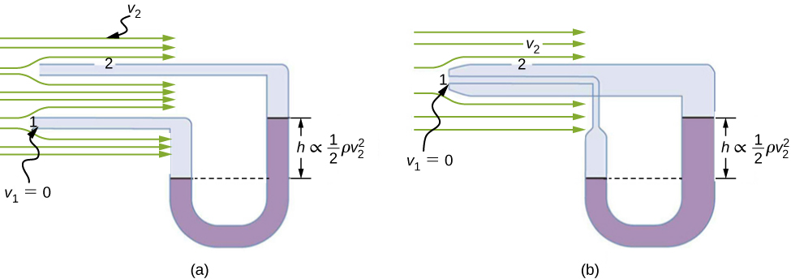

Solution

Let  be the initial wind speed and  be the final wind speed. 

Yes, the wind speed factor is independent of the moving fluid and the fluid in the manometer.

1. If the pressure reading of your pitot tube is 15.0 mm Hg at a speed of 200 km/h, what will it be at 700 km/h at the same altitude?

Solution

–135 mm Hg

1. Every few years, winds in Boulder, Colorado, attain sustained speeds of 45.0 m/s (about 100 mph) when the jet stream descends during early spring. Approximately what is the force due to the Bernoulli equation on a roof having an area of 220 m2? Typical air density in Boulder is 1.14 kg/m3, and the corresponding atmospheric pressure is 8.89 × 104 N/m2. (Bernoulli’s principle as stated in the text assumes laminar flow. Using the principle here produces only an approximate result, because there is significant turbulence.)

Solution



1. What is the pressure drop due to the Bernoulli Effect as water goes into a 3.00-cm-diameter nozzle from a 9.00-cm-diameter fire hose while carrying a flow of 40.0 L/s? (b) To what maximum height above the nozzle can this water rise? (The actual height will be significantly smaller due to air resistance.)

Solution

a. ; b. 163 m

1. (a) Using Bernoulli’s equation, show that the measured fluid speed *v* for a pitot tube, like the one in part B of the following image, is given by , where *h* is the height of the manometer fluid,  is the density of the manometer fluid,  is the density of the moving fluid, and *g* is the acceleration due to gravity. (Note that *v* is indeed proportional to the square root of *h*, as stated in the text.) (b) Calculate *v* for moving air if a mercury manometer’s *h* is 0.200 m.



Solution

a. proof; b. 144 m/s

1. A container of water has a cross-sectional area of *A* = 0.1 m2. A piston sits on top of the water (see the following figure). There is a spout located 0.15 m from the bottom of the tank, open to the atmosphere, and a stream of water exits the spout. The cross sectional area of the spout is  (a) What is the velocity of the water as it leaves the spout? (b) If the opening of the spout is located 1.5 m above the ground, how far from the spout does the water hit the floor? Ignore all friction and dissipative forces.

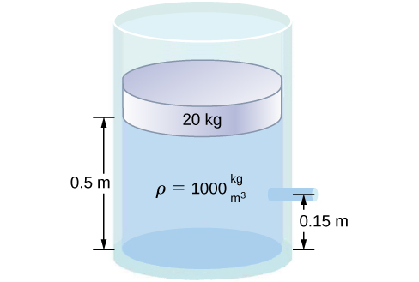

Solution

a.





;

b.



1. A fluid of a constant density flows through a reduction in a pipe. Find an equation for the change in pressure, in terms of , and the density.

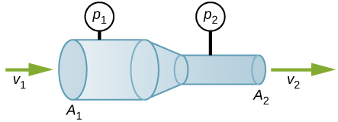

Solution









]

1. Calculate the retarding force due to the viscosity of the air layer between a cart and a level air track given the following information: air temperature is 20 °C, the cart is moving at 0.400 m/s, its surface area is 2.50 × 10–2 m2, and the thickness of the air layer is 6.00 × 10–2 m. (b) What is the ratio of this force to the weight of the 0.300-kg cart?

Solution

a. ; b. 

1. The arterioles (small arteries) leading to an organ constrict in order to decrease flow to the organ. To shut down an organ, blood flow is reduced naturally to 1.00% of its original value. By what factor do the radii of the arterioles constrict?

Solution



1. A spherical particle falling at a terminal speed in a liquid must have the gravitational force balanced by the drag force and the buoyant force. The buoyant force is equal to the weight of the displaced fluid, while the drag force is assumed to be given by Stokes Law, . Show that the terminal speed is given by ,where *R* is the radius of the sphere,  is its density, and  is the density of the fluid, and  the coefficient of viscosity.

Solution

proof

1. Using the equation of the previous problem, find the viscosity of motor oil in which a steel ball of radius 0.8 mm falls with a terminal speed of 4.32 cm/s. The densities of the ball and the oil are 7.86 and 0.88 g/mL, respectively.

Solution



1. A skydiver will reach a terminal velocity when the air drag equals his or her weight. For a skydiver with a large body, turbulence is a factor at high speeds. The drag force then is approximately proportional to the square of the velocity. Taking the drag force to be  and setting this equal to the skydiver’s weight, find the terminal speed for a person falling “spread eagle.”

Solution

40 m/s

1. Verify that a 19.0% decrease in laminar flow through a tube is caused by a 5.00% decrease in radius, assuming that all other factors remain constant. (b) What increase in flow is obtained from a 5.00% increase in radius, again assuming all other factors remain constant?

Solution

a. ~19% decrease in flow; b. 21.6% increase in flow

1. When physicians diagnose arterial blockages, they quote the reduction in flow rate. If the flow rate in an artery has been reduced to 10.0% of its normal value by a blood clot and the average pressure difference has increased by 20.0%, by what factor has the clot reduced the radius of the artery?

Solution

;The radius is reduced to 53.7% of its normal value.

1. An oil gusher shoots crude oil 25.0 m into the air through a pipe with a 0.100-m diameter. Neglecting air resistance but not the resistance of the pipe, and assuming laminar flow, calculate the pressure at the entrance of the 50.0-m-long vertical pipe. Take the density of the oil to be 900 kg/m3 and its viscosity to be  (or ). Note that you must take into account the pressure due to the 50.0-m column of oil in the pipe.

Solution

(gauge pressure)

1. Concrete is pumped from a cement mixer to the place it is being laid, instead of being carried in wheelbarrows. The flow rate is 200 L/min through a 50.0-m-long, 8.00-cm-diameter hose, and the pressure at the pump is 8.00 × 106 N/m2. (a) Calculate the resistance of the hose. (b) What is the viscosity of the concrete, assuming the flow is laminar? (c) How much power is being supplied, assuming the point of use is at the same level as the pump? You may neglect the power supplied to increase the concrete’s velocity.

Solution

a. ; b. ; c. 

1. Verify that the flow of oil is laminar for an oil gusher that shoots crude oil 25.0 m into the air through a pipe with a 0.100-m diameter**.** The vertical pipe is 50 m long. Take the density of the oil to be 900 kg/m3 and its viscosity to be  (or ).

Solution

. To find 

Now, 

Since  is the approximate upper value for laminar flow, the flow of oil is laminar (barely).

1. Calculate the Reynolds numbers for the flow of water through (a) a nozzle with a radius of 0.250 cm and (b) a garden hose with a radius of 0.900 cm, when the nozzle is attached to the hose. The flow rate through hose and nozzle is 0.500 L/s. Can the flow in either possibly be laminar?

Solution

(a. Nozzle: 



Flow is not laminar.

b. Hose: 



Flow is not laminar.

1. A fire hose has an inside diameter of 6.40 cm. Suppose such a hose carries a flow of 40.0 L/s starting at a gauge pressure of 1.62 × 106 N/m2. The hose goes 10.0 m up a ladder to a nozzle having an inside diameter of 3.00 cm. Calculate the Reynolds numbers for flow in the fire hose and nozzle to show that the flow in each must be turbulent.

Solution

Hose: 

Flow is turbulent.

Nozzle: 

Flow is turbulent.

1. At what flow rate might turbulence begin to develop in a water main with a 0.200-m diameter? Assume a  temperature.

Solution



**Additional Problems**

1. Before digital storage devices, such as the memory in your cell phone, music was stored on vinyl disks with grooves with varying depths cut into the disk. A phonograph used a needle, which moved over the grooves, measuring the depth of the grooves. The pressure exerted by a phonograph needle on a record is surprisingly large. If the equivalent of 1.00 g is supported by a needle, the tip of which is a circle with a 0.200-mm radius, what pressure is exerted on the record in Pa?

Solution



1. Water towers store water above the level of consumers for times of heavy use, eliminating the need for high-speed pumps. How high above a user must the water level be to create a gauge pressure of 3.00 × 105 N/m2?

Solution

30.6 m

1. The aqueous humor in a person’s eye is exerting a force of 0.300 N on the  area of the cornea. What pressure is this in mm Hg?

Solution

20.5 mm Hg

1. (a) Convert normal blood pressure readings of 120 over 80 mm Hg to newtons per meter squared using the relationship for pressure due to the weight of a fluid  rather than a conversion factor. (b) Explain why the blood pressure of an infant would likely be smaller than that of an adult. Specifically, consider the smaller height to which blood must be pumped.

Solution

a. ;

b. Since an infant is only approximately 20 inches tall, while an adult is approximately 70 inches tall, the blood pressure for an infant would be expected to be smaller than that of an adult. The blood only feels a pressure of 20 inches rather than 70 inches, so the pressure should be smaller.

1. Pressure cookers have been around for more than 300 years, although their use has greatly declined in recent years (early models had a nasty habit of exploding). How much force must the latches holding the lid onto a pressure cooker be able to withstand if the circular lid is  in diameter and the gauge pressure inside is 300 atm? Neglect the weight of the lid.

Solution

 atmospheric pressure outside the cooker can be ignored, since we are given the gauge pressure inside, and the gauge pressure indicates pressure above atmospheric. So, 3 atm measures the pressure difference between the inside and outside of the lid.

1. Bird bones have air pockets in them to reduce their weight—this also gives them an average density significantly less than that of the bones of other animals. Suppose an ornithologist weighs a bird bone in air and in water and finds its mass is 45.0 g and its apparent mass when submerged is 3.60 g (assume the bone is watertight). (a) What mass of water is displaced? (b) What is the volume of the bone? (c) What is its average density?

Solution

a. 41.4 g; b. 41.4 cm3; c. 1.09 g/cm3. This is clearly not the density of the bone everywhere. The air pockets will have a density of approximately 1.29 × 10–3 g/cm3, while the bone will be substantially denser.

1. In an immersion measurement of a woman’s density, she is found to have a mass of 62.0 kg in air and an apparent mass of 0.0850 kg when completely submerged with lungs empty. (a) What mass of water does she displace? (b) What is her volume? (c) Calculate her density. (d) If her lung capacity is 1.75 L, is she able to float without treading water with her lungs filled with air?

Solution

a. 61.9 kg; b. 0.0619 m3; c. 1.00 × 103 kg/m3; d. Yes, she will float without treading water when her lungs are full.

1. Some fish have a density slightly less than that of water and must exert a force (swim) to stay submerged. What force must an 85.0-kg grouper exert to stay submerged in salt water if its body density is 1015 kg/m3?

Solution

12.3 N

1. The human circulation system has approximately  capillary vessels. Each vessel has a diameter of about . Assuming cardiac output is 5 L/min, determine the average velocity of blood flow through each capillary vessel.

Solution

0.166 cm/s

1. The flow rate of blood through a -radius capillary is . (a) What is the speed of the blood flow? (b) Assuming all the blood in the body passes through capillaries, how many of them must there be to carry a total flow of ?

Solution

a. . (This small speed allows time for diffusion of materials to and from the blood.) b.  capillaries. (This large number is an overestimate, but it is still reasonable.)

1. The left ventricle of a resting adult’s heart pumps blood at a flow rate of 83.0 cm3/s, increasing its pressure by 110 mm Hg, its speed from zero to 30.0 cm/s, and its height by 5.00 cm. (All numbers are averaged over the entire heartbeat.) Calculate the total power output of the left ventricle. Note that most of the power is used to increase blood pressure.

Solution

1.26 W

1. A sump pump (used to drain water from the basement of houses built below the water table) is draining a flooded basement at the rate of 0.750 L/s, with an output pressure of 3.00 × 105 N/m2. (a) The water enters a hose with a 3.00-cm inside diameter and rises 2.50 m above the pump. What is its pressure at this point? (b) The hose goes over the foundation wall, losing 0.500 m in height, and widens to 4.00 cm in diameter. What is the pressure now? You may neglect frictional losses in both parts of the problem.

Solution

a. ; b. *P*2 = 2.81 × 105 N/m2

1. A glucose solution being administered with an IV has a flow rate of 4.00 cm3/min. What will the new flow rate be if the glucose is replaced by whole blood having the same density but a viscosity 2.50 times that of the glucose? All other factors remain constant.

Solution



1. A small artery has a length of 1.1 × 10–3 m and a radius of 2.5 × 10–5 m. If the pressure drop across the artery is 1.3 kPa, what is the flow rate through the artery? (Assume that the temperature is .)

Solution

8.7 × 10–2 mm3/s

1. Angioplasty is a technique in which arteries partially blocked with plaque are dilated to increase blood flow. By what factor must the radius of an artery be increased in order to increase blood flow by a factor of 10?

Solution



1. Suppose a blood vessel’s radius is decreased to 90.0% of its original value by plaque deposits and the body compensates by increasing the pressure difference along the vessel to keep the flow rate constant. By what factor must the pressure difference increase? (b) If turbulence is created by the obstruction, what additional effect would it have on the flow rate?

Solution

a.1.52; b. Turbulence would decrease the flow rate of the blood, which would require an even larger increase in the pressure difference, leading to higher blood pressure.

**Challenge Problems**

1. The pressure on the dam shown early in the problems section increases with depth. Therefore, there is a net torque on the dam. Find the net torque.

Solution





1. The temperature of the atmosphere is not always constant and can increase or decrease with height. In a neutral atmosphere, where there is not a significant amount of vertical mixing, the temperature decreases at a rate of approximately 6.5 K per km. The magnitude of the decrease in temperature as height increases is known as the lapse rate  (The symbol is the upper case Greek letter gamma.) Assume that the surface pressure is  where and the lapse rate is . Estimate the pressure 3.0 km above the surface of Earth.

Solution





















1. A submarine is stranded on the bottom of the ocean with its hatch 25.0 m below the surface. Calculate the force needed to open the hatch from the inside, given it is circular and 0.450 m in diameter. Air pressure inside the submarine is 1.00 atm.

Solution



1. Logs sometimes float vertically in a lake because one end has become water-logged and denser than the other. What is the average density of a uniform-diameter log that floats with 20.0% of its length above water?

Solution

800 kg/m3

1. Scurrilous con artists have been known to represent gold-plated tungsten ingots as pure gold and sell them at prices much below gold value but high above the cost of tungsten. With what accuracy must you be able to measure the mass of such an ingot in and out of water to tell that it is almost pure tungsten rather than pure gold?

Solution

in water: 0.1092%; out of water: 0.1035% in air; 5 digits of accuracy to determine the difference between gold and tungsten

1. The inside volume of a house is equivalent to that of a rectangular solid 13.0 m wide by 20.0 m long by 2.75 m high. The house is heated by a forced air gas heater. The main uptake air duct of the heater is 0.300 m in diameter. What is the average speed of air in the duct if it carries a volume equal to that of the house’s interior every 15 minutes?

Solution

11.2 m/s

1. A garden hose with a diameter of 2.0 cm is used to fill a bucket, which has a volume of 0.10 cubic meters. It takes 1.2 minutes to fill. An adjustable nozzle is attached to the hose to decrease the diameter of the opening, which increases the speed of the water. The hose is held level to the ground at a height of 1.0 meters and the diameter is decreased until a flower bed 3.0 meters away is reached. (a) What is the volume flow rate of the water through the nozzle when the diameter is 2.0 cm? (b) What is the speed of the water coming out of the hose? (c) What does the speed of the water coming out of the hose need to be to reach the flower bed 3.0 meters away? (d) What is the diameter of the nozzle needed to reach the flower bed?

Solution

a. The volume flow rate is  , ;

b. The speed of the water is , ;

c. The speed of the water needs to be

, , ;

d. The diameter of the nozzle is , 

1. A frequently quoted rule of thumb in aircraft design is that wings should produce about 1000 N of lift per square meter of wing. (The fact that a wing has a top and bottom surface does not double its area.) (a) At takeoff, an aircraft travels at 60.0 m/s, so that the air speed relative to the bottom of the wing is 60.0 m/s. Given the sea level density of air as , how fast must it move over the upper surface to create the ideal lift? (b) How fast must air move over the upper surface at a cruising speed of 245 m/s and at an altitude where air density is one-fourth that at sea level? (Note that this is not all of the aircraft’s lift—some comes from the body of the plane, some from engine thrust, and so on. Furthermore, Bernoulli’s principle gives an approximate answer because flow over the wing creates turbulence.)

Solution

a. 71.8 m/s; b. 257 m/s

1. Two pipes of equal and constant diameter leave a water pumping station and dump water out of an open end that is open to the atmosphere (see the following figure). The water enters at a pressure of two atmospheres and a speed of . One pipe drops a height of 10 m. What is the velocity of the water as the water leaves each pipe?

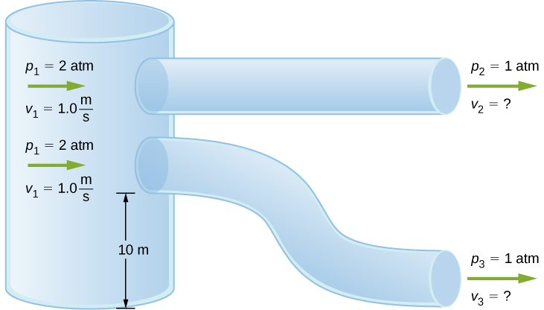

Solution











1. Fluid originally flows through a tube at a rate of . To illustrate the sensitivity of flow rate to various factors, calculate the new flow rate for the following changes with all other factors remaining the same as in the original conditions. (a) Pressure difference increases by a factor of 1.50. (b) A new fluid with 3.00 times greater viscosity is substituted. (c) The tube is replaced by one having 4.00 times the length. (d) Another tube is used with a radius 0.100 times the original. (e) Yet another tube is substituted with a radius 0.100 times the original and half the length, and the pressure difference is increased by a factor of 1.50.

Solution

a.  ; b.  ; c.  ; d.  ; e. 

1. During a marathon race, a runner’s blood flow increases to 10.0 times her resting rate. Her blood’s viscosity has dropped to 95.0% of its normal value, and the blood pressure difference across the circulatory system has increased by 50.0%. By what factor has the average radii of her blood vessels increased?

Solution



1. Water supplied to a house by a water main has a pressure of  early on a summer day when neighborhood use is low. This pressure produces a flow of 20.0 L/min through a garden hose. Later in the day, pressure at the exit of the water main and entrance to the house drops, and a flow of only 8.00 L/min is obtained through the same hose. (a) What pressure is now being supplied to the house, assuming resistance is constant? (b) By what factor did the flow rate in the water main increase in order to cause this decrease in delivered pressure? The pressure at the entrance of the water main is , and the original flow rate was 200 L/min. (c) How many more users are there, assuming each would consume 20.0 L/min in the morning?

Solution

a. ; b. The flow rate in the main increases by 90%. c. There are approximately 38 more users in the afternoon.

1. Gasoline is piped underground from refineries to major users. The flow rate is 3.00 × 10–2 m3/s (about 500 gal/min), the viscosity of gasoline is  and its density is 680 kg/m3. (a) What minimum diameter must the pipe have if the Reynolds number is to be less than 2000? (b) What pressure difference must be maintained along each kilometer of the pipe to maintain this flow rate?

Solution

a. 13.0 m; b. 

This file is copyright 2016, Rice University. All Rights Reserved.